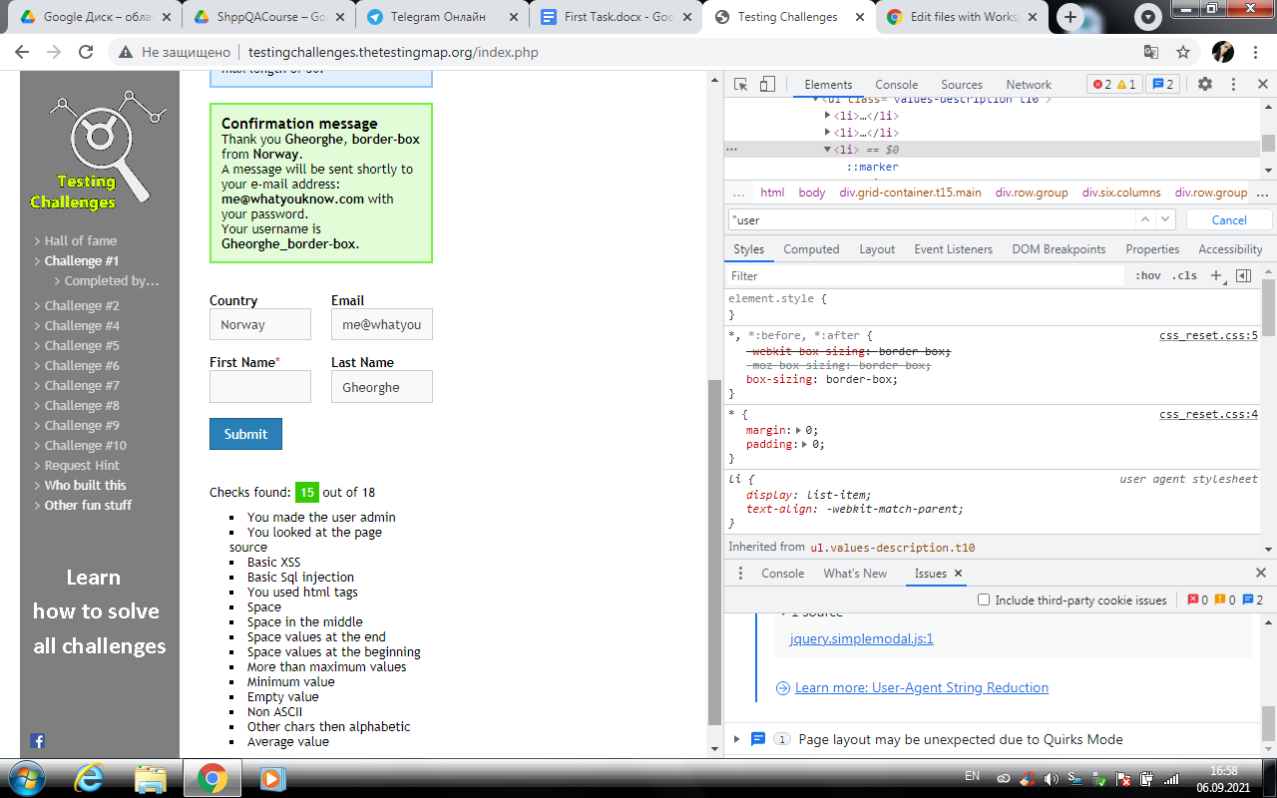

**Bug-reports**

|  | |
| --- | --- |
| **Status:** | Open |
| **Project:** | <http://testingchallenges.thetestingmap.org/> |

| **Type:** | Bug | **Priority:** | Minor |
| --- | --- | --- | --- |
| **Reporter:** | Tymoshenko Yelyzaveta | **Assignee:** | Tymoshenko Yelyzaveta |
| **Resolution:** | Unresolved | **Votes:** | 0 |
| **Environment:** | Google chrome version 90.0.4430.93  Windows 7 Ultimat  Screen resolution: 1280х800 | | |

| **Description** |  |
| --- | --- |

| **Purpose:** Check interface  **Pre-conditions:**   1. Go to the site 2. Be on the home page of the site   **Steps to reproduce:**   1. On the page that opens, the control panel is layered on the text.   **Expected result:** When opening the page, all panels are in their places.  **Actual result:** When opening a page, the control panel is shifted up the left corner. |
| --- |

